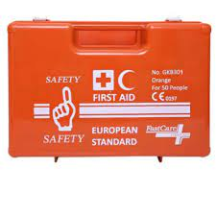

Safety First GKB301 European Standard First Aid Kit for 25 people

It consists of
- Din 13168-D – 1 Packet
- Surgical Gloves – 1Packet
- Round Banded – 1 Roll
- Bandage – 1 Packet
- Instant Cold Pack – 1 Packet
- Alcohol Pre-Pad – 5 pcs
- Sterile Gauze Pad Small – 3 Packet
- Sterile Gauze Pad Medium – 3 Packet
- Sterile Gauze Pad Large – 3 Packet
- Scissor – 1 Pair
- Safety Pin – 4pcs
- Small Band-Aid – 15pcs
- Plastic With Round Band-Aid – 1pc

